|  |  |
| --- | --- |
| **Name:- Aryan Dilipbhai Langhanoja** | **Roll Number:- 92200133030** |
| **Subject Name and Code:-** Foundation Skills On Sensor Interfacing (01CT1103) | **Date of Experiment:- 11-12-2022** |

|  |  |
| --- | --- |
| Task:- |  |

* Interface 16x2 LCD and temperature & humidity sensor with arduino uno development board and observe the data on LCD.

|  |  |
| --- | --- |
| Components: |  |

* Arduino Uno R3
* 16 X 2 I2C LCD Display
* Jumper Wires (Male To Male)
* Temperature Sensor.
* Laptop Or PC

|  |  |
| --- | --- |
| About the Project:- |  |

* In thisproject, we are going to interface 16 x 2 LCD Display with Arduino and Get the Readings of temperature Sensor on It. For That WE Will Connect the VCC with +5V and GND to the Ground. SDA and SCL Pin will be connected to the last two pins of Arduino.
* Now, we will connect the Temperature Sensor with Arduino. For that we will connect The Signal Pin we will connect to the Analog Pin A0 and Power pin to +5V and Ground Pin To GND.

|  |  |
| --- | --- |
| Schematic:- |  |

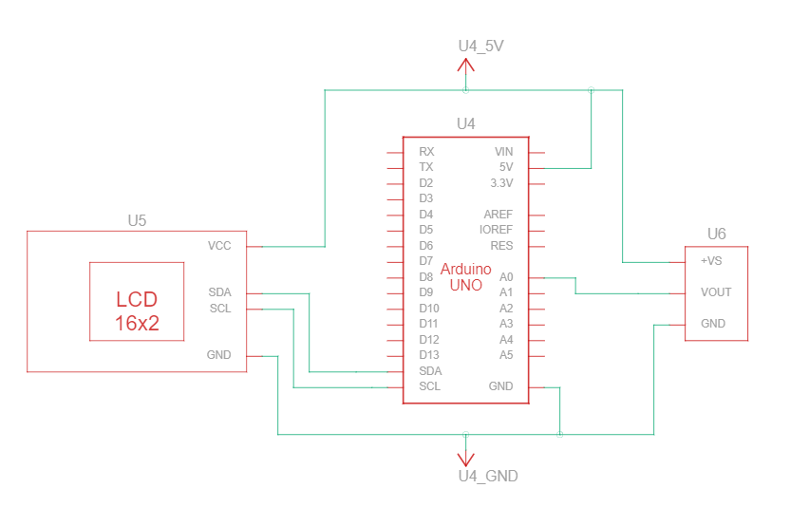

|  |  |  |
| --- | --- | --- |
| Output:- (you circuit implementation |  |  |

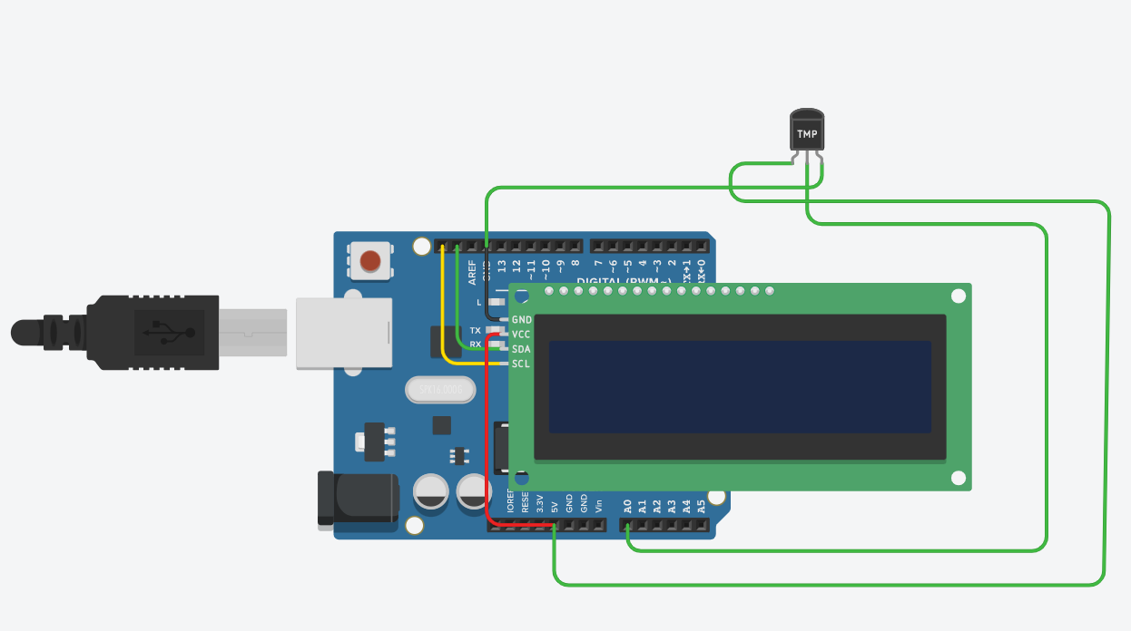

|  |  |
| --- | --- |
| Code:- |  |

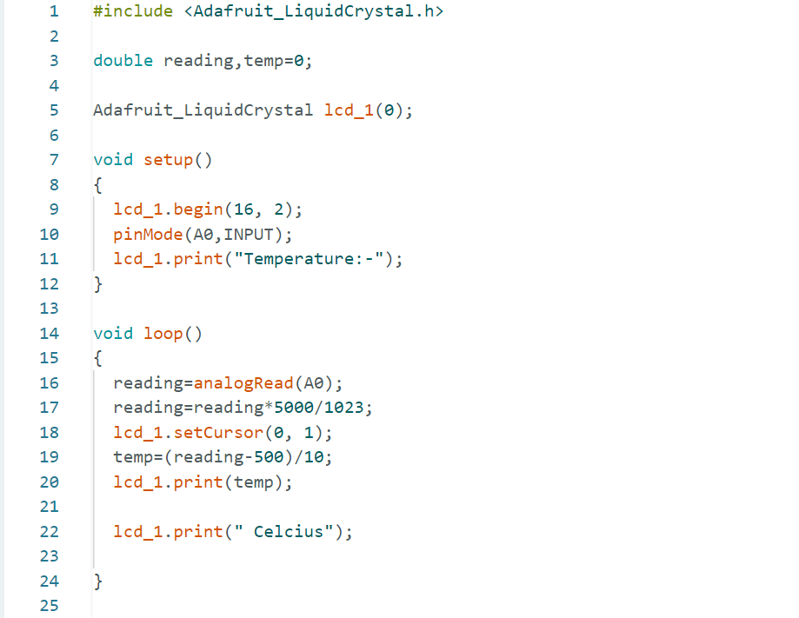

|  |  |
| --- | --- |
| Conclusion:- |  |

* In This Experiment, We Learnt That How To Get Readings of temperature Sensor’s Reading on LCD.